Group Programming Project II

CS150 Computer Programming for the Liberal Arts

Fall 2022

100 points

Choose any program from the following list:

Step 1: Set up a group of two or three.

Step 2: Give a 2-minute presentation on what are the building blocks on 11/04/22 in class.

Step 3: Present the logic at class (11/09/22) in 5 minute and submit the programming project via Moodle by 11/10/21.

**Question 1. Water Bucket Puzzle:**

Suppose you have 8L, 5L and a 3L bucket with you. The buckets have no measurement lines on them, and you are asked to measure exactly 4L of water using the three buckets. How could you measure exactly 4L water using only those buckets and provided you have as much extra water as you need?

**Question 2. Periodic Table**

The periodic table of the elements organizes all known chemical elements into a single table. Write a program that will represents periodic table. You can keep as much information about the elements you will like. Make the table little colorful.

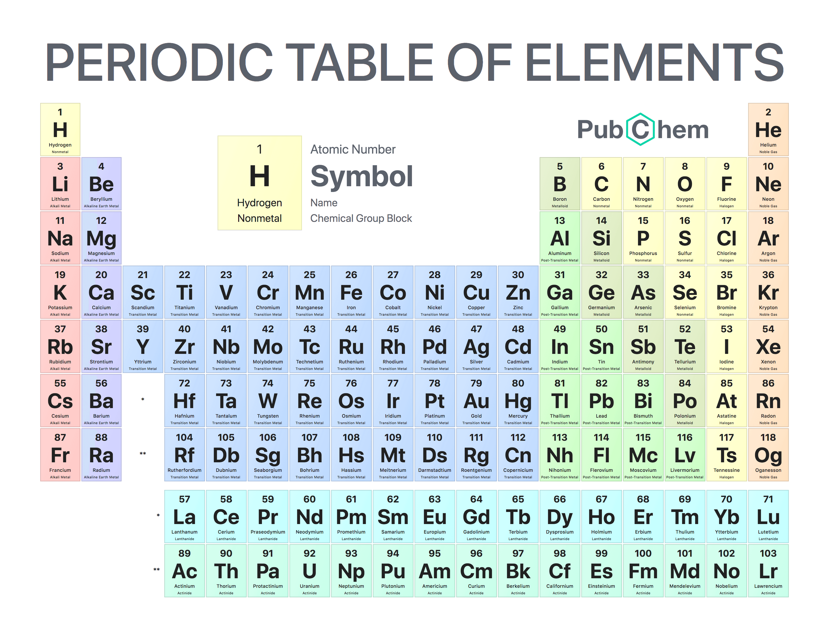

**Question 3. Caesar Cipher**

In cryptography, a Caesar cipher, also known as Caesar's cipher, the shift cipher, Caesar's code or Caesar shift, is one of the simplest and most widely known encryption techniques. Write a program that will encrypt a message using Caesar Cipher and also use Brute Force Technique to hack encrypted message.

**Question 4. Powerball Lottery**

The Powerball Lottery is an exciting way to lose small amounts of money. If you purchase a $2 ticket, you can pick six numbers: five drawn from 1 to 69, and a sixth “Powerball” number drawn from 1 to 26. The order of the numbers doesn’t matter. Design a game of Powerball lottery.

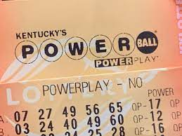

**Question 5: The Magic Fortune Ball**

The Magic Fortune Ball that can predict the future and answer your yes/no questions with 100 percent accuracy.

